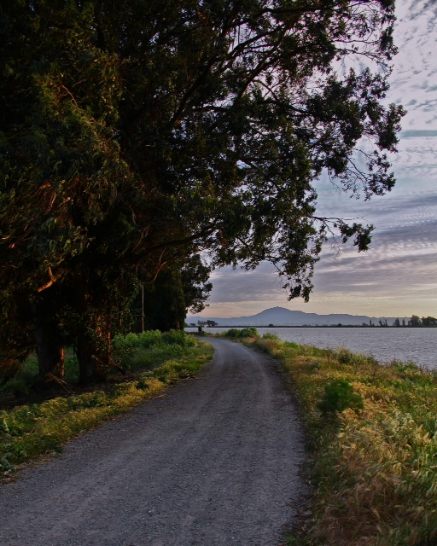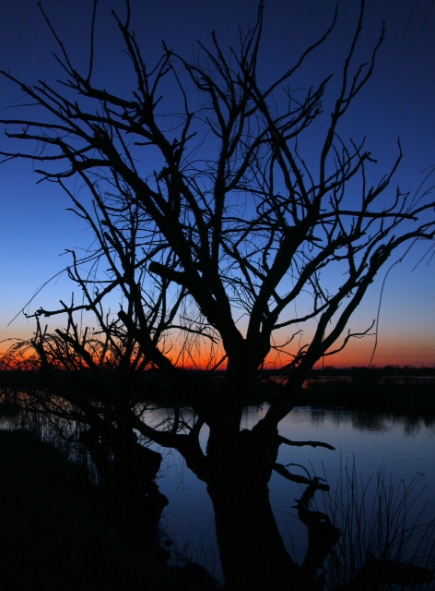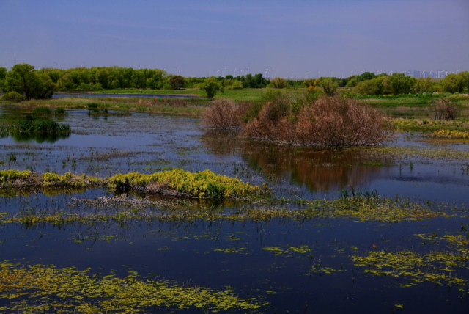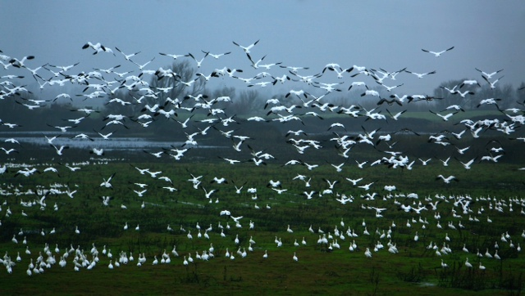

Assessment due with property taxes:

1st due 12/10/2014

2nd due 4/10/2015

We are fast approaching the conclusion of our levee upgrade work. It has been an eventful summer, with construction happening along almost every section of our levee. Once the project is completed our levees will meet FEMAS minimum 100-year flood protection standard. There will also be additional reinforcement work done along False River for additional protection in the event a salinity barrier is needed. A generous “Thank You’ to residents, contractors, and staff for the coordination and patience.

# Photos courtesy of Michael Craig

# Levee Improvement Project Update

Bradford Is. News

**RECLAMATION DISTRICT 2059**

**6325 Bethel Island Rd, Suite A**

**Bethel Island, CA 94511**

**(925) 684-3222**

### the

**Remember when we learned genetic code?**

**As spirals started curving on their inward line,**

**We found our rhythm on the levee road.**

**The turns we wandered down were slow and wide**

**Fog’s cooling labyrinth a lazy rhyme,**

**But delta water wasn’t all that flowed.**

**I cut the engine, but the headlights showed**

**a way through mist. Not certain of the time, we felt the rhythm on the levee road.**

**From farm hard by the river, a cock crowed**

**To celebrate the moon’s mistaken rise.**

**The delta water wasn’t all that flowed.**

**That night we shifted, learning one seed sowed**

**Could grow in soil where we could improvise.**

**We danced the rhythm of the levee road.**

**Between the current and the land we road**

**The edge of what had been, to seabird’ cries,**

**And delta water wasn’t all that flowed.**

**We found our rhythm on the levee road.**

### *Delta Song*

### By Bob Stanley

Make sure your voice is heard. Board meetings are held the 1st Tuesday of each mo. @ 10:00 A.M. Located at the District Office. We welcome the public.

#### Save the Date!

Assessments 14/15

Election – date TBD. No Trustee terms expiring. Voting on By-laws only. (See article, pg 2)

Election, 2014

FALL 2014

## **By Laws**

The District has been operating under the original By Laws from its formation in 1921. A committee was formed to review and amend the By Laws to bring them into compliance with current law. These amended By Laws require approval by a majority of the landowners, therefore a date will be set for an election at the next Trustee Board meeting scheduled for September 2, 2014. Please contact District Administrator Angelia Tant for more information.

General Revenue: $324,730.55

Ferry Ticket Sales: $16,000.00

General/Subventions Expenses: $133,545.43

Ferry Expenses: $109,432.49

## **2013/14 Year End Financial Report**

In 2010, a majority of the landowners passed a Proposition 218 election to change the assessment from an “ad valorem” or assessed value basis to a more equalized, special benefit basis, where each parcel is assessed based on the amount of special benefit derived according to the parcel land use code.

This Proposition 218 increased assessments to allow the District to rebuild the pump station, do needed ditch cleaning and levee maintenance, and purchase flood fighting supplies but it had a 5-yr sunset clause. The current assessment expires May, 2015 at which time it reverts back to the 1976 ad valorem amount unless another Proposition 218 is held. In order to maintain our financial status, the District needs to once again do a Proposition 218 election. In July the Board passed a resolution to extend an RFP for engineering services to conduct a “post Prop-218” election by May 2015. Stay tuned for updates.

## **Prop 218**

###### Your Trustees and Committee members have worked hard to update the regulations and By Laws under which we operate. Read More…

The District’s Encroachment Regulations have been updated to include new definitions as well as clarification of certain terms for landowner and District education. The Committee will continue to meet to develop District Standards for encroachments in order to streamline the permitting process. The new Regulations will be posted and available on the website.

## **Encroachment Regulations**

# DISTRICT HIGHLIGHTS

#### Meet Your Team

Board President and Treasurer: Cate Kuhne

Delta Ferry Authority Representative: Rob Davies

Trustees: Michael Craig

William Hall

Gilbert Orozco

District Legal Counsel: Mia Brown

District Program Manager: Smith Cunningham

District Engineer: Dominick Gulli

District Administrator and Board Secretary: Angelia Tant

Sandhill Cranes and sometimes ducks, swans and geese, as well as shorebirds, feed in the marshy grazing fields of Bradford Island. Swainsons, Cooper and Red Tail hawks have often been seen patrolling overhead, and there has even been sighting of a bald eagle along our shores.

The Audubon Society has identified the Sacramento/San Joaquin Delta as an Important Bird Site (IBA). These 213,301 acres, of which Bradford Island is a part, provide a diverse and essential habitat for birds. “As such they establish a useful framework for helping guide efforts to conserve birds statewide.”

“Audubon California has used the best science to identify and map these Important Bird Areas. Part of an international effort, these sites were nominated by local experts and selected according to strict criteria:

* Support over 1% of the global or 10% of the state population of one or more sensitive species
* Support more than nine sensitive bird species
* 10,000 or more observable shorebirds in one day
* 5,000 or more observable waterfowl in one day”

Not only do we have the Audubon Society working to preserve our native species, the Nature Conservancy has increased its efforts to conserve critical wintering habitat for sandhill cranes, shorebirds and other migratory birds with its restoration of over 25,000 acres of habitat and its eco-friendly farm on Staten Island. Read more at the web sites below:

<http://ca.audubon.org/protecting-bird-habitat-bay-delta-region>

<http://www.nature.org/ourinitiatives/regions/northamerica/unitedstates/california/howwework/californias-delta-a-water-source-for-most-californians.xml>

# Migratory Path

Make sure to check out the District’s Website for:

Agendas

Current & Historical Meeting Minutes

Encroachment permit applications

Rules & Regulations

Ferry Information

www.bradfordisland.com

FALL 2014

THE BRADFORD IS. NEWS

RECLAMATION DISTRICT 2059

PO BOX 346  
BETHEL ISLAND, CA 94511

Emailed to: Agenda List/Landowner List

Posted on Bradford’s website

[Recipient]